Student Name: ________________________

Unit 3: Systems

Lesson 1: Core Technologies

File 3.1.5: Ohm’s Law and Basic Circuits Worksheet

Electrical and electronic technologies utilize Ohm’s law to explain the relationship between voltage, current, and resistance. The formula for Ohm’s Law is represented below:

Ohm’s Law = V = I x R
V = voltage (units=volts) I = current (units=amps) R = resistance (units=ohms)

Practice
Using Ohm’s Law, solve the following problems. Be sure to show your work.
- A nine-volt battery supplies power to a cordless blow dryer with a resistance of 18 ohms. How much current is flowing through the blow dryer?

- A 110-volt wall outlet supplies power to a black light with a resistance of 4400 ohms. How much current is flowing through the black light?

Designers and engineers use Ohm’s Law to determine the specific electrical and electronic components needed in a circuit, depending on the desired purpose. Basic circuits contain four parts (Figure 1): power source, conductor, control, and load (output).

Figure 1

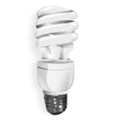
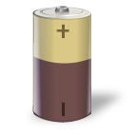
Conductor
Power Source
Load (output)

Control

Series and parallel circuits are the common types of circuits. See Figure 2 for images of both series and parallel circuits.

Figure 2
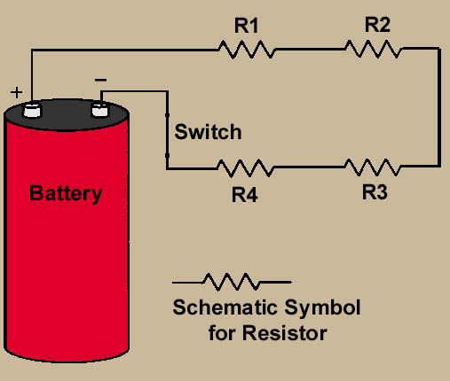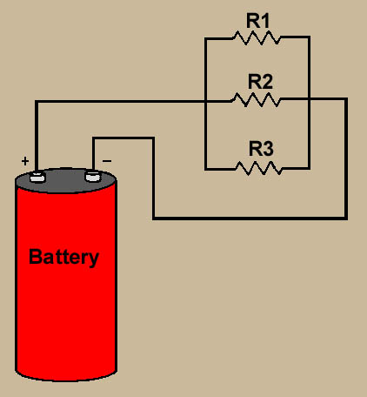
Series Circuit Parallel Circuit

- Compare and contrast the images above using the Venn diagram below. What is similar, what is different?

Application
- What do you think would happen if a light burns out in a series circuit?

- What do you think would happen if a light burns out in a parallel circuit?

Reflection on the Design Challenge
- What might you use as a load (output) for your Rube Goldberg device? Include the purpose of the output in your description.

- Would a series or parallel circuit be needed to turn on the output from question 4? Draw a sketch of a possible circuit.

