Lesson 1: Inventions and Innovations: An Evolutionary Process
File 1.1.2: Research and Development Funding Change
Analyze the following graph from the National Science Foundation depicting funding for Research and Development for the United States from 1960 to 1998.
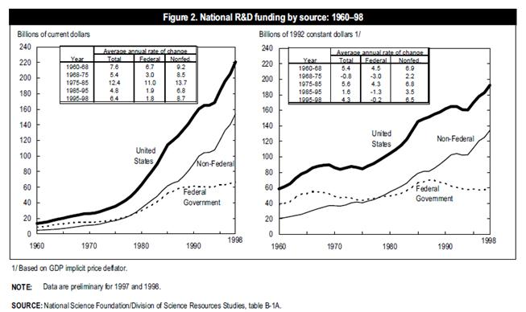

Think, Pair, Share
- Think: Individually, take two minutes to interpret the graph. Consider the following question: What conclusions can you draw upon based on the data shown?
- Pair: With a student close to you, share your reflections with one another.
Consider the following questions: What surprised you? What factors do you think contributed to the data? What didn’t surprise you? What conclusions did you both agree upon?
- Share: Be prepared to share your discussion with the class.

