Student Name: ________________________

Unit 4: Design

Lesson 2: Design Process

File 4.2.1: Engineering Design Process

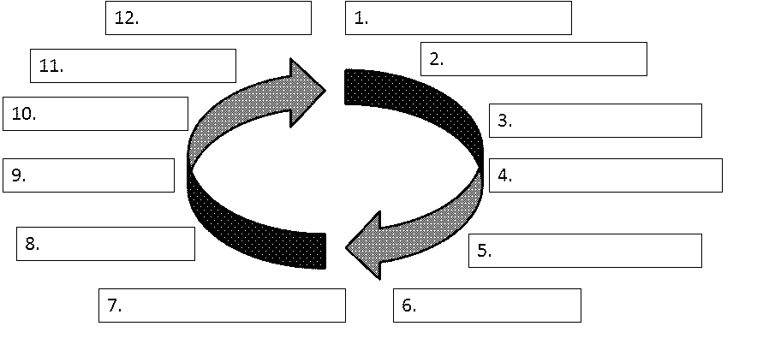

Word Bank

Select an Approach
Communicate Processes and Results
Define the Problem
Refine the Design
Make a Model or Prototype
Brainstorm
Create/Make It
Explore Possibilities
Research and Generate Ideas
Test and Evaluate the Design Using Specifications
Identify Criteria and Specify Constraints
Develop a Design Proposal

